Report: Median Housing Price Model for D. M. Pan National Real Estate Company
Student’s name
Affiliated institution
Instructor’s name
Course
Date of submission

Report: Median Housing Price Prediction Model for D. M. Pan National Real Estate Company
Introduction
The purpose to this report is to come up with a model to analyze median house costs D. M. Pan National Real Estate homes sold in 2019. The model will permit this organization to comprehend and utilize the square footage as a benchmark for determining the costs on homes in a particular area. The real estate national data offers a very important insight of the data collected from 50 counties around United States this enabling the estimation of correlation between the price listing and median square foot. The Company ought to provide their client with detailed information that will help them gain competitive advantage against other real estate firms by utilizing the square footage to determine the price listing for the homes. My aim is to utilize this data and establish linear regression in real world to present to the Real Estate Company correlation between median square footage of each of the randomly selected 50 counties and price listing of the homes. The objective is to elucidate whether the sample of N50 counties selected randomly will represent the N 978 counties covered in the U.S real estate nation al data set. The outlier will be discovered to decipher the reason for some counties deviating so much from the linear regression. The linear regression presented a straight line showing the correlation that can real help the real estate in determining the market values.
Data Collection
The sample data used in this analysis was derived from the real estate data 2019. The samples were selected randomly using Microsoft excel. The samples were selected from 978 counties in U.S using random function to get the property list within the area. The function that was used in this analysis was =RAND (). I created a random number column and assigned the random function to every row. Through tis I was able to sort the rows through filter option. I managed to select the 50 counties that were generated in the list to determine the median, mean and standard deviation of the median square feet and price median listing for the properties. A scatter plot chat was developed from this data using predictor median square feet as X-axis and variable of price median listing as Y response

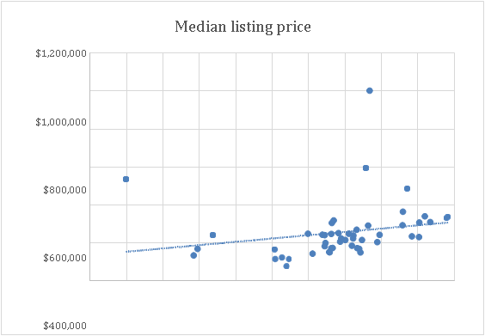

Data Analysis
In this report we are dissecting data that was gathered cross country with an end goal to capture the trend in housing market value. This is required for the realtors to comprehend the

2019 real estate market, make forecasts on estimations of future home deals, and comprehend the data outliers that we are given to acquire the competitive advantage it takes to for this business to flourish and sampled counties.
The data set offer sufficient information regarding the factors to set up an example that can utilized to construct a disperse plot. Our factors comprise of the median posting costs of homes all through a few provinces just as the size of home in median square feet. The pattern line of the scatter plot inclines to the right hence positive correlation between the factors. The record value and the square feel of the homes are positively correlated. The X variable (otherwise called the indicator variable, and our Y variable otherwise called response variable, increment, and an example of a characterized straight line starts to create framing linear regression

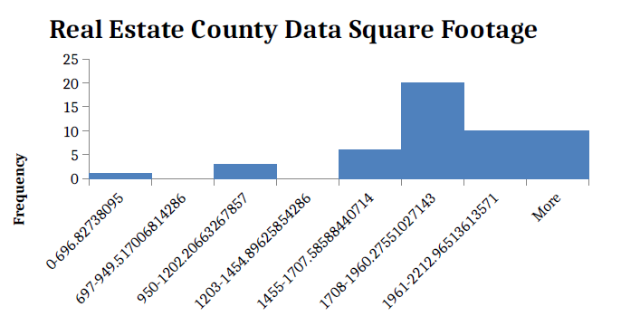

Median Square Feet
Frequency
Boundaries of MSF Frequency
0 - 696.82738095 1
697 - 949.517006814286 0
950 - 1202.20663267857 3
1203 - 1454.89625854286 0
1455 - 1707.58588440714 6
1708 - 1960.27551027143 20
1961 - 2212.96513613571 10
More 10

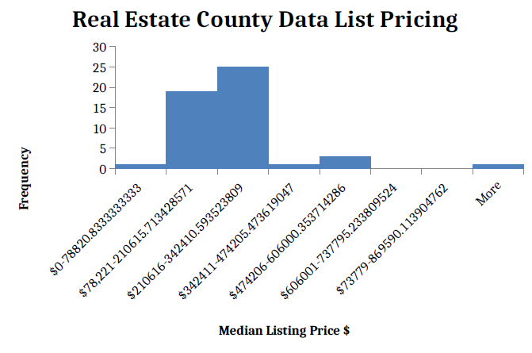
Median Listing Price $
Frequency
Boundaries of MLP$ Frequency
$0 - 78820.8333333333 1
$78,221 - 210615.713428571 19
$210616 - 342410.593523809 25
$342411 - 474205.473619047 1
$474206 - 606000.353714286 3
$606001 - 737795.233809524 0
$73779 - 869590.113904762 0
More 1
medi  an listing price $ |  | medi  an $'s per square foot |  | median square feet
 | $ |  | $
Mean | 256,360.82 | Mean | 126.58 | Mean | 1873.97
 | $ |  | $
Median | 233,238.67 | Median | 112.13 | Median | 1889.955
Standard | $ | Standard | $ | Standard
Deviation | 147,342.74 | Deviation | 76.05 | Deviation | 351.4945
 | $ |  | $
Minimum | 78,820.83 | Minimum | 44.78 | Minimum | 696.8274
 | $
 | 1,001,384.9 |  | $
Maximum | 9 | Maximum | 526.35 | Maximum | 2465.655
Count | 50 | Count | 50 | Count | 50

The histogram developed assumed bell shape. This implies that our information comprised of 1 variable (median square footage) ought to be symmetrical fit as a fiddle and bell shaped. The histogram distributions are valid and do not have outliers. For this situation however, the graph has 4 exceptions making the histograms appear to be unimodal and slanted to one side, changing the shape. The histogram is negative skewed which diminishes the distribution gap size of samples of 50 counties. It has a wave shape rather than a bell shape, and it is more difficult to track down the gradient and the interception of the line found in the equation of linear regression. It will not be as precise with 4 outliers which are available in the main histogram, which is negatively skewed. The estimation of the mean is not exactly the medians in the initial histogram since it is skewed to the left. The center of focus histogram is 1878 square feet. This was realized by listing the property size in ascending order and determining the median.
We discovered this by rattling off our property sizes from littlest to biggest and tracking down the median number. The motivation behind choosing the median to determine the focal point of our histogram is because the anomalies skew the graph and influence the mean, though they do not influence the median. The spread is the value obtained smaller median square foot from the largest square foot.
The other histogram was made to illustrate the random sample and the listing median prices for the 2019 national real estate data which is positively skewed to the right. The median listing at the center of the histogram is $231,376. And a spread of $922,564 which is the difference between the largest and the smallest listing median pricing. This factor gives the IQR, with the 4 outliers making the spread to be skewed. Looking at the histogram with regard to the national population, there is correlation between the histograms created from both samples. The histogram for the median listing prices is skewed to the right. The reason being, that every county was represented random sample data.
Utilizing 5% of the 2019 data for real estate of the sample, appears to be more ideal to utilize 10%. Histogram of median square footage is unique in relation to the public populace's median footage for some reasons. One integral explanation is the sample histogram is contrarily skewed, while the national populace histogram is balanced. Since the nature of the national populace is even, it's ideal that we utilize median to track down the center of this histogram, which is 1944 square feet. This is additionally unique in light of the fact that our sample histogram had various exceptions, and this populace histogram did not, which is the reason for the using the median rather than the mean to track down the center for the histogram. The national data spread is 3248 square feet, while the spread of the samples was 1796 square feet. This distinction could likewise be credited to areas that have larger homes at less expensive costs, and on the grounds that we just inspected 50 randomized counties out of 978, we don't have the information to present this data.

The Regression Model
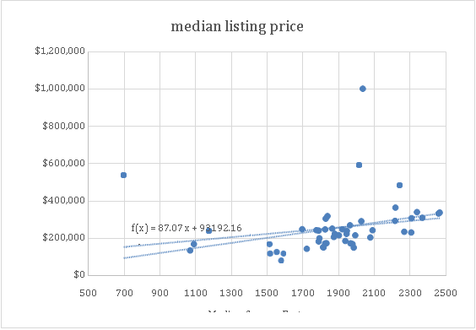

This chart shows a genuinely straight line with both the X and Y factors slanting together, through the plots. There is clear correlation between independent and dependent variables. Past the anomalies, independent variable (Median square feet) increases beyond the outliers and, so does the dependent variables (median listing cost). Linear regression will be used as the statistical procedure enable D.M. pan National Real Estate Company understand the market value of 2019 real estate.
Scatter plot has a positive correlation. There is a positive link between the square feet of a home and it’s recorded worth. From the scatterplot, there are 4 significant exceptions. Anomalies adversely affect the data analysis since it influences correlation magnitude between the factors. The scatterplot have a correlation coefficient of 0.207713. This implies that there is a uphill certain linear correlation between the factors to the trendlines of the chart. The most grounded correlation coefficient is - 1 or 1. The factors that we are examining are the middle area on the X-axis, and the middle posting cost on the -axis. For this situation r=0.207713 where the value of r is greater or equal to 0.2 but less than 0.4 which reveals the strength of the relationship is weak.
The Line of Best Fit
The Regression Equation for this scatter plot is Y = 87.071x + 93192.
In this equation 87.071 is the incline boundary, and 93192 is the interception boundary, and X (median square feet) is the informative variable in this scatter plot. As X changes, so wont Y
The R² Coefficient gives the proportion of the change in the reaction variable which is clarified by the indicator variable. The R² coefficient = 0.0431.
This implies that the coefficient of assurance is exceptionally low clarifying 4.31% of the variety of the two factors.
Y = 87.071(2300) + 93192 If I were to utilize linear regression would be recorded for roughly $293,455. This posting cost with this area would land us directly on the pattern line. Something that is truly fascinating is that Harrison province WV has a middle.
Posting cost of $172,565 for a home with 1824 middle square feet. Subsequent to connecting these figures to our straight condition, our trendlines says this house is really worth about $252,009. This is just about a $80,000 spread between the information's middle posting cost and the trendlines recommended esteem.
Conclusion
. The National measurements median square feet histogram has a chime curve and with normal distribution, while the curve for median square feet histogram is skewed. The exceptions in the data makes the histogram be less reliable during the analysis. The measurements for median posting cost and sample data both have their curves that are skewed to the positive. The inquiry I have is how we might eliminate these exceptions to modify our outcomes without our data getting one-sided.

